Chapter 1 Reading Task
Identify the keyword in the question. What is the question actually asking?
What type of word is this? Why does it stand out?

How does Bruno feel about moving?
‘Say goodbye to them?’ he asked, staring at her in surprise.
‘Say goodbye to them?’ he repeated, spluttering out the words as
if his mouth was full of biscuits that he’d munched into tiny pieces
but not actually swallowed yet. ‘Say goodbye to Karl and
Daniel and Martin?’ he continued, his voice coming dangerously
close to shouting, which was not allowed indoors.
‘But they’re my three best friends for life!’
Do you think Bruno’s parents are strict? Explain your answer.
What does this phrase suggest about Bruno’s feelings? Support with a keyword.
What does this tell us about Bruno’s feelings? Which word stands out?

Chapter 2 Reading Task
New House | Old House
Chapter 2 Reading Task
Quote Explosions
‘This isn’t home and it never will be.’
What type of sentence is this? Why is it effective?
What type of word is this? What does it mean?

‘He wanted nothing more than to crawl inside it and hope that when he climbed out again he’d have woken up and be back home again.’
What does this quotation tell us about Bruno’s feelings?
What type of word is this? What does it suggest?

Now try explaining and exploding these quotations:
- ‘As if he was in the loneliest place in the world.’
- ‘There was nothing to laugh at and nothing to be happy about.’
- ‘Now he was stuck here in this cold, nasty house.’
- ‘Bruno had a pain in his stomach and he could feel something growing inside him …’
- ‘He felt as if he was about to cry again but stopped himself, not wanting to look like a baby.’

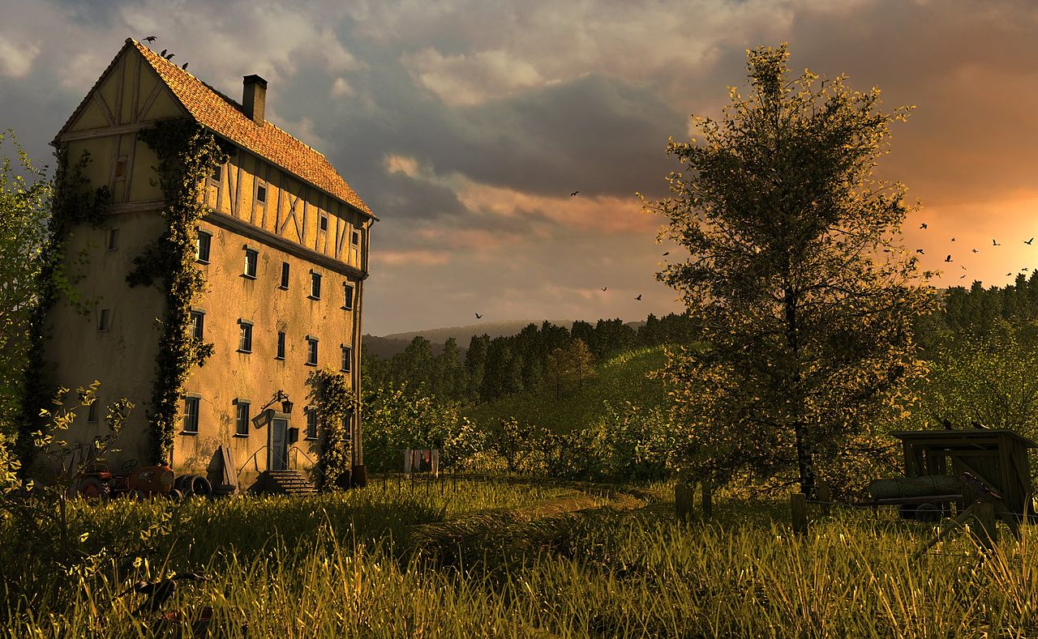
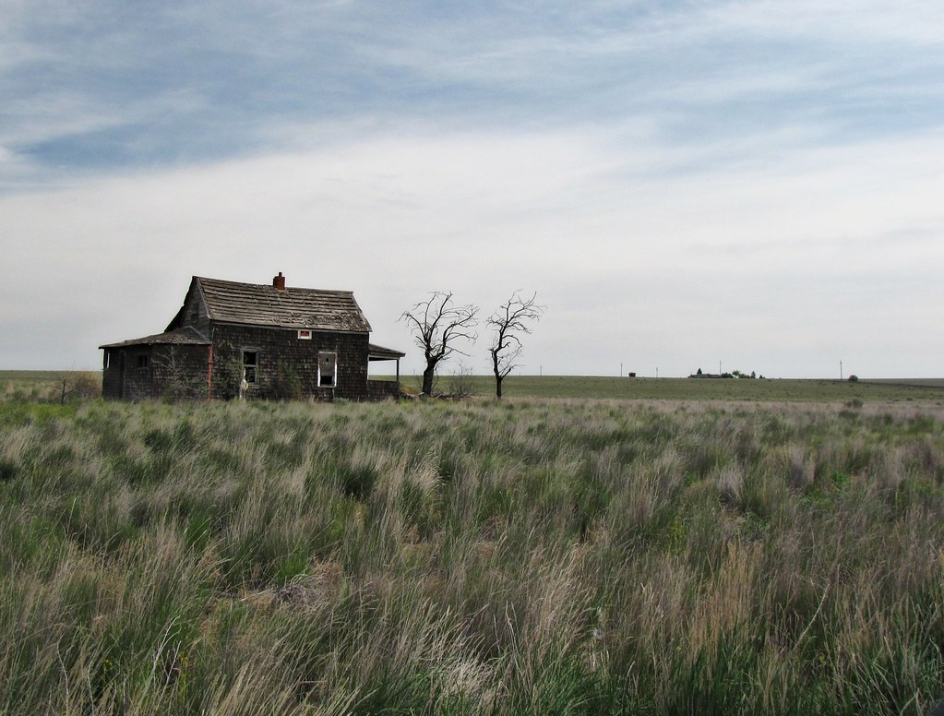
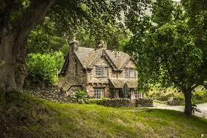
Chapter 2 Writing Task
‘he was in the loneliest place in the world’
‘everything around him just felt empty and cold’
‘the new house had only three floors’
‘no other families ... no other boys to play with’
‘stood all on its own in an empty, desolate place’

Chapter 3 Reading Task
EXTENSION
Can you find and copy any evidence from the story to support your adjectives and explanations? Write these around the outside.
PALM
Explain why you have chosen each adjective.
FINGERS
Adjectives to describe Gretel: E.g. Nasty, frightening, bossy etc.

Chapter 3 Reading Task

How does the writer show Gretel’s fear and uncertainty?

Gretel was still a few feet away and desperately wanted to look for herself, but something about the way he had said it and something about the way he was watching made her feel suddenly nervous. Bruno had never been able to trick her before about anything and she was fairly sure that he wasn’t tricking her now, but there was something about the way he stood that made her feel as if she wasn’t sure she wanted to see those children at all. She swallowed nervously and said a silent prayer that they would indeed be returning to Berlin in the foreseeable future and not in a month as Bruno suggested.

- What does fear and uncertainty mean?
- What type of word is ‘desperately’? What does it suggest about Gretel’s behaviour?
- Gretel felt ‘suddenly nervous’. Which word stands out and why?
- Why do you think she didn’t want to see the children after all?
- Gretel ‘swallowed nervously and said a silent prayer’. Why might she have done this? How does it link to fear and uncertainty?

Writing a PEE paragraph – Point, Evidence, Explain
Point: The writer shows Gretel’s … (use key words in the question)
Evidence: I know this because it says … (choose a quotation and copy it correctly)
Explain: This means/suggests … (explain and link to the question)

Now try your own with another quotation

Chapter 4 Reading Task

Bruno’s new house | Outside the window
- There was a garden directly beneath Bruno’s window.  - Full of flowers which grew in neat orderly sections in soil.  - Like putting a tiny candle of light in the corner of a huge castle on a misty moor on a dark winter’s night.  - Past the flowers there was a very pleasant pavement with a wooden bench.  - Gretel could imagine sitting in the sunshine and reading a book. | - There was a huge wire fence that ran along the length of the house.  - The fence was very high, higher even than the house they were standing in.  - At the top of the fence enormous bales of barbed wire were tangled in spirals.  - There was no greenery anywhere to be seen.  - The ground was made of a sand-like substance.

What are your impressions of each setting? Look carefully at the words that are highlighted and think about their effects.

Everywhere they looked they could see people, tall, short, old, young, all moving around. Some stood perfectly still in groups, their hands by their sides, trying to keep their heads up, as a soldier marched in front of them, his mouth opening and closing quickly as if he were shouting something at them. Some were formed into a sort of chain gang and pushing wheelbarrows from one side of the camp to the other, appearing from a place out of sight and taking their wheelbarrows further along behind a hut, where they disappeared again. A few stood near the huts in quiet groups, staring at the ground as if it was the sort of game where they didn’t want to be spotted. Others were on crutches and many had bandages around their heads. Some carried spades and were being led by groups of soldiers to a place where they could no longer be seen.

Now what impression do you get of this place from your reading of the text? Does it link to the description above?
- Highlight key words and phrases from the text above to support your ideas.
- Think about what they mean and why the writer might have chosen them.
- Have a go at writing your own PEE paragraph based on your learning so far.
Chapter 5 Reading Task

How is Bruno’s father presented in the following extracts?

Appearance
Down below he saw the door open to Father’s office standing open and a group of five men outside it, laughing and shaking hands. Father was at the centre of them and looked very smart in his freshly pressed uniform. His thick dark hair has obviously been recently lacquered and combed, and as Bruno watched from above he felt both scared and in awe of him. He didn’t like the look of the other men quite as much. They certainly weren’t as handsome as Father. Nor were their uniforms as freshly pressed. Nor were their voices so booming or their boots so polished.
Power
Father held a hand up in the air, which immediately caused the other men to fall silent. It was as if he was the conductor or a barbershop quartet.
‘Gentlemen,’ he said, and this time Bruno could make out every word because there had never been a man born who was more capable of being heard from one side of a room to the other than Father. ‘Your suggestions and your encouragement are very much appreciated. And the past is the past. Here we have a fresh beginning, but let that start tomorrow. For now, I’d better help my family settle in or there will be as much trouble for me in here as there is for them out there, you understand?’

Things to think about
- Think about how he presents himself and what this suggests
EXTENSION
Does this view link to how he is described earlier in the story?

- Look closely at Bruno’s father’s choice of language
- Think about how he talks to the other men
- Write your point – use the question to help you
- Choose some evidence from the text above
- Explain what your evidence means
- Repeat

