The Bromfords School

23 March 2022

Dear Parents/Carers,

Re: Appointment of Headteacher

The Local Governing Body of The Bromfords School is delighted to announce the appointment of Mr Jochen Tree as Headteacher of our school. The formal appointment will commence from Monday 28 March 2022.

Following his appointment, Mr Tree said:

“It is an absolute privilege to have the opportunity to lead The Bromfords School and Sixth Form College and I would like to thank the Governing Body and Trustees for this wonderful opportunity.

The last two years have been challenging for all of us for so many reasons but my core values remain based on every member of the school community aspiring to be the best they can be, in everything they do.

This is an exciting time for the school with a waiting list for Year 7 places in September and a high number of applications for our Sixth Form. I look forward to working with you all to continue to move the school forward.”

The appointment committee conducted a very stringent and rigorous two-day interview process which involved governors, staff, students, external advisors along with trustees from Compass Education Trust, to ensure that anyone appointed had the ability and acumen to lead and further improve the school for the benefit of all those entrusted in our care.

At the end of day two, it was unanimously agreed by the recruitment committee that Mr Tree met all our requirements in every way.

We will continue in our endeavours to ensure that all students achieve the very best that they can and leave us ready to take an active part in the community.

Yours sincerely,

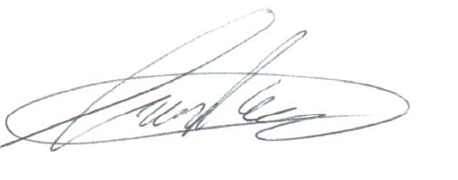
Mr Tony Parfett
Chair of Governors

The Bromfords School and Sixth Form College is an academy within

“Compass Education Trust Ltd” which is a charitable company limited by guarantee.
Company number 07666213. Registered office, The Billericay School, School Road, Billericay, Essex, CM12 9LH

