PERSON SPECIFICATION
Learning Support Assistant
Experience | - Successful recent experience working with secondary age children  - Working effectively as part of a team
Qualifications | - NVQ Level 2 ( or equivalent) in Mathematics and English (E)  - NVQ Level 2 in learning support or other equivalent qualification (D)  - Good general standard of education – GCSE or equivalent (E)
Knowledge & Skills | - Basic knowledge of first aid  - Understanding of child protection policies and procedures  - Knowledge of relevant codes of practice and school policies  - Knowledge of basic ICT to support learning
Aptitudes | - Work effectively as part of a team and contribute to group thinking, planning etc.  - Effective time management  - Build rapport with adults and children  - To demonstrate skills of empathy  - To be flexible  - Follow instructions accurately  - Use own initiative and work independently  - Communicate effectively with adults and children, verbally and in writing  - Motivate, inspire and have high expectations of pupils  - Work calmly under pressure  - Committed to personal and professional development  - Awareness of, and commitment to, equalities issues  - Ability to record and assess pupil progress/performance etc.

The Bromfords School and Sixth Form College is an academy within

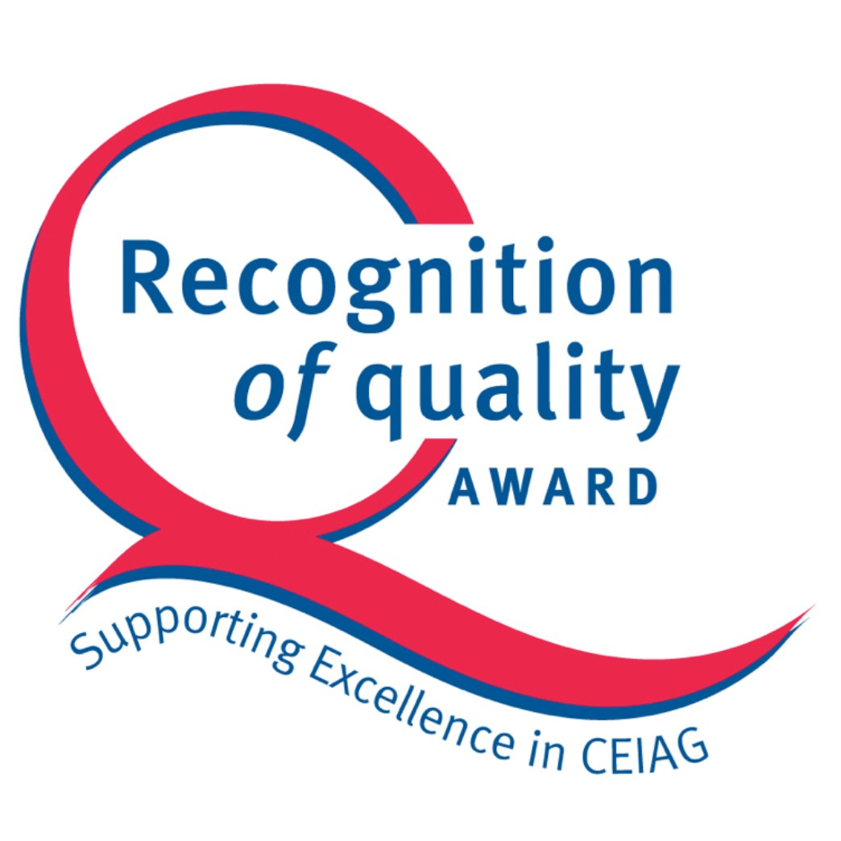

“Compass Education Trust Ltd” which is a charitable company limited by guarantee.
Company number 07666213. Registered office,
The Billericay School, School Road, Billericay, Essex, CM12 9LH

