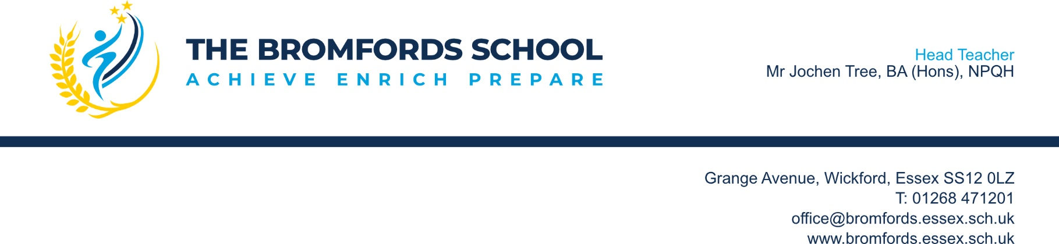

Dear Parent/Carer,

“If you would not like to receive it do not send it”

I am writing to explain our joint Home School Policy regarding electronic forms of social media.

As you will be aware, over recent years there has been a significant growth in electronic forms of communication such as Facebook, TikTok, Snapchat, Instagram, houseparty, WhatsApp, BBM, Text message and any other internet based communication platforms.

Along with the growth in the use of these types of communication, there has also been a marked increase in the number of criminal offences committed by people who misuse electronic communications. Offences linked to technology can be committed under the Telecommunications Act, Malicious Communications Act, the Protection of Children Act or the Criminal Justice Act. For example, advances in technology have enabled offenders to quickly share and ‘trade’ indecent images of children. Once convicted, some of these offences require the offender to sign onto the Sex Offenders Register.

There have been occasions when young people have used their ‘technology’ inappropriately and this has led to the school having to take formal action and impose sanctions against students. The local police have assisted the school on occasions with such matters.

I would therefore like to take this opportunity at the start of the new term to outline to you the stance that the school takes on social media and the consequences for any student that breaches our Policy.

In order to be eligible to sign up for Facebook, Instagram and Tik Tok you must be at least 13 years old. The school will not support the use of this or similar sites for students under 13 years old.

You will be aware from national media that there have been occasions when social media sites have been misused to commit acts of bullying and harassment towards others – any such behaviour brought to the attention of our school will be positively dealt with and may be referred to the police.

We would also encourage you as parents and carers to set a positive example to your children in the use of social media sites so that they can learn how to use the sites without getting in trouble or becoming a victim themselves.

Chats, conversations, and other messages that you believe to be private can be hacked into, screen printed and shared with other users, or forwarded to people outside of friendship groups. This in turn can cause other offences to be committed. Students should never send pictures of themselves that could be considered ‘indecent’ (partially or totally naked) as these images once sent cannot be retrieved and do cause both the sender and receiver to commit potential criminal offences.

We would also encourage you to talk with your child about the dangers of ‘webcams’ – some children don’t even realise they have a camera on their IPad or other technology and do not know they could be being watched or traced.

The consequences of misusing social media may lead to school exclusion or a criminal record which has far reaching implications - future employers can request criminal record checks and this can hinder students from getting a good job, going on to further education, travelling or obtaining personal finance.

Like you, we want to ensure our school is a safe learning environment for all of our students. The safeguarding of our students will always be of paramount importance to all of the staff.

We therefore urge you to read and discuss the contents of this letter with your child to ensure they fully understand the implications of it and can keep themselves safe from inadvertently committing criminal acts or becoming victims themselves.

If you would like further advice on how to keep your child safe on the internet, we would recommend you visit the following:-

https://www.ceop.police.uk/safety-centre/ - Child Exploitation and Online Protection command is part of the National Crime Agency and is there to help you if you are worried about online abuse or the way someone is communication with you or your child online.

https://www.thinkuknow.co.uk/ - “Thinkuknow” is the education programme from NCA-CEOP, a UK organisation which protects children both online and offline.

Yours faithfully

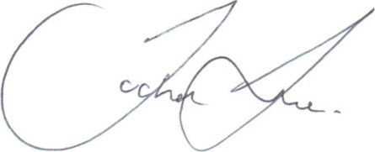
Mr Jochen Tree
Headteacher

